- Configure Classic Load balancer
A Classic Load Balancer, or CLB, is an old AWS load balancer used to distribute incoming traffic across multiple EC2 instances

Part 1: Check your VPC CIDR

Step 1: Open VPC service
Go to:
AWS Console → Search VPC → Open VPC

Step 2: Go to Your VPCs
Click:
Your VPCs
Select your VPC, usually:
default-vpc

Step 3: Check IPv4 CIDR
In details, check:
IPv4 CIDR
Example:
172.31.0.0/16
or
10.0.0.0/16

Purpose
Your subnet CIDR must come inside the VPC CIDR.
Example:
VPC CIDR: 172.31.0.0/16
Subnet CIDR: 172.31.100.0/24
This is valid because 172.31.100.0/24 is inside 172.31.0.0/16.

Part 2: Create one subnet

Step 4: Go to Subnets
In VPC console, left side:
Subnets → Create subnet

Step 5: Select VPC
Choose your VPC:
VPC ID: default-vpc
or the VPC where your EC2/load balancer will be created.

Purpose
Subnet belongs to one VPC. Your EC2 and Load Balancer must use the same VPC.

Step 6: Add subnet details
Enter:
Subnet name: public-subnet-clb-1
Availability Zone: ap-south-1a
IPv4 subnet CIDR block: 172.31.100.0/24
Use your own region/AZ. Example:
If your region is Mumbai: ap-south-1a
If your region is N. Virginia: us-east-1a

Important
Your subnet CIDR depends on your VPC CIDR.
If your VPC CIDR is:
172.31.0.0/16
Use:
172.31.100.0/24
If your VPC CIDR is:
10.0.0.0/16
Use:
10.0.1.0/24

Purpose
This creates a new IP range where EC2 and Load Balancer can be placed.
A /24 subnet gives around 251 usable IP addresses because AWS reserves some IP addresses in every subnet.

Step 7: Click Create subnet
Click:
Create subnet
Now your subnet is created.
But it is not fully public yet.

Part 3: Make the subnet public
For a subnet to be public, it needs a route to an Internet Gateway. AWS says a public subnet needs a route like 0.0.0.0/0 → internet gateway.

Step 8: Check Internet Gateway
Go to:
VPC → Internet gateways
Check if your VPC already has an Internet Gateway attached.
You should see something like:
igw-xxxxxxxx
State: Attached
VPC: your VPC ID

Purpose
Internet Gateway allows internet traffic in and out of your VPC.
AWS explains that an internet gateway allows resources in public subnets to connect to the internet when they have a public IPv4 address.

Step 9: If Internet Gateway is not available, create one
Only do this if your VPC does not already have one.
Go to:
Internet gateways → Create internet gateway
Name:
my-vpc-igw
Click:
Create internet gateway
Then select it and click:
Actions → Attach to VPC
Choose your VPC and click:
Attach internet gateway

Purpose
Without Internet Gateway, your public subnet cannot access the internet.

Part 4: Create route table for the subnet

Step 10: Go to Route Tables
Go to:
VPC → Route tables → Create route table
Enter:
Name: public-rt-clb
VPC: your VPC
Click:
Create route table

Purpose
Route table controls where subnet traffic should go. AWS route tables decide how traffic is routed from your subnet to other networks.

Step 11: Add route to Internet Gateway
Select the route table:
public-rt-clb
Go to:
Routes → Edit routes → Add route
Add:
Destination: 0.0.0.0/0
Target: Internet Gateway
Target value: igw-xxxxxxxx
Click:
Save changes

Purpose
This makes the subnet public.
Meaning:
Traffic going to internet → send to Internet Gateway

Step 12: Associate route table with your subnet
Select route table:
public-rt-clb
Go to:
Subnet associations → Edit subnet associations
Select your new subnet:
public-subnet-clb-1
Click:
Save associations

Purpose
Now your new subnet uses the public route table.
Your subnet is now a public subnet.

Part 5: Enable auto-assign public IPv4

Step 13: Go to Subnets
Go to:
VPC → Subnets
Select:
public-subnet-clb-1
Click:
Actions → Edit subnet settings
Enable:
Auto-assign public IPv4 address
Click:
Save

Purpose
When you launch an EC2 instance into this subnet, it will automatically get a public IP.
This is useful for testing from browser and SSH.

Part 6: Launch EC2 in this new subnet

Step 14: Go to EC2
Go to:
AWS Console → EC2 → Instances → Launch instances

Step 15: Name the instance
Name: WebServer-CLB

Step 16: Choose AMI
Select:
Amazon Linux 2023

Step 17: Choose instance type
t2.micro
or
t3.micro

Step 18: Choose key pair
Select your key pair.

Step 19: Network settings
Click:
Edit
Select:
VPC: same VPC
Subnet: public-subnet-clb-1
Auto-assign public IP: Enable

Purpose
This places your EC2 instance inside the subnet we created.

Step 20: Security group
Create security group:
Name: webserver-clb-sg
Description: Allow SSH and HTTP
Inbound rules:
Type | Port | Source | Purpose
SSH | 22 | My IP | To connect to server
HTTP | 80 | 0.0.0.0/0 | To test web page
Click:
Launch instance

Part 7: Install Apache on EC2

Step 21: Connect to EC2
Go to:
EC2 → Instances → Select WebServer-CLB → Connect
Choose:
EC2 Instance Connect → Connect

Step 22: Install Apache
Run:
sudo yum update -y
sudo yum install httpd -y
sudo systemctl start httpd
sudo systemctl enable httpd

Step 23: Create test page
Run:
echo "Hello from EC2 in new public subnet" | sudo tee /var/www/html/index.html

Step 24: Check Apache
Run:
sudo systemctl status httpd
You should see:
active (running)
Press:
q

Part 8: Test EC2 before Load Balancer

Step 25: Copy EC2 public IP
Go to:
EC2 → Instances → Select WebServer-CLB
Copy:
Public IPv4 address
Open browser:
http://EC2-Public-IP
You should see:
Hello from EC2 in new public subnet

Purpose

Part 8: Test EC2 before Load Balancer

Step 25: Copy EC2 public IP
Go to:
EC2 → Instances → Select WebServer-CLB
Copy:
Public IPv4 address
Open browser:
http://EC2-Public-IP
You should see:
Hello from EC2 in new public subnet

Purpose
Before adding load balancer, we confirm EC2 is working inside the new subnet
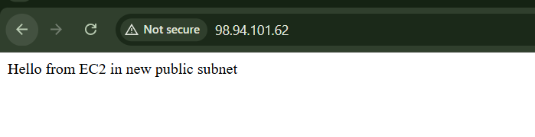
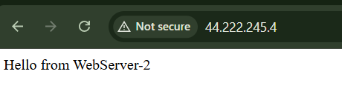

Part 9: Create Classic Load Balancer using this subnet

Step 26: Go to Load Balancers
Go to:
EC2 → Load Balancers → Create load balancer
Choose:
Classic Load Balancer → Create

Step 27: Configure basic details
Enter:
Load Balancer name: my-classic-lb
Scheme: Internet-facing
VPC: same VPC
Listener:
Load Balancer Protocol: HTTP
Load Balancer Port: 80
Instance Protocol: HTTP
Instance Port: 80

Step 28: Select the subnet/AZ
In Availability Zones/Subnets section, select:
Availability Zone: same AZ as public-subnet-clb-1
Subnet: public-subnet-clb-1
Example:
ap-south-1a → public-subnet-clb-1

Purpose
This assigns your Classic Load Balancer to the subnet you created.
Load balancers accept client traffic and route it to registered targets like EC2 instances in enabled Availability Zones.

Step 29: Assign Load Balancer security group
Create new security group:
Name: classic-lb-sg
Description: Allow HTTP to Classic Load Balancer
Inbound rule:
Type | Port | Source
HTTP | 80 | 0.0.0.0/0

Purpose
This allows users to access the load balancer from browser.

Step 30: Configure health check
Use:
Ping Protocol: HTTP
Ping Port: 80
Ping Path: /
Response Timeout: 5
Interval: 30
Unhealthy Threshold: 2
Healthy Threshold: 2

Purpose
The Load Balancer checks whether Apache is working on EC2.

Step 31: Add EC2 instance
Select:
WebServer-CLB
Click:
Add to registered instances

Step 32: Add tags
Add:
Key | Value
Name | my-classic-lb

Step 33: Review and create
Check:
VPC: same VPC
Subnet: public-subnet-clb-1
Listener: HTTP 80
Health check: HTTP 80 /
Instance: WebServer-CLB
Click:
Create Load Balancer

Part 10: Verify Load Balancer

Step 34: Check instance status
Go to:
EC2 → Load Balancers → my-classic-lb → Instances
Wait until:
InService

Step 35: Copy Load Balancer DNS
Go to:
Description → DNS name
Open:
http://Load-Balancer-DNS
You should see:
Hello from EC2 in new public subnet

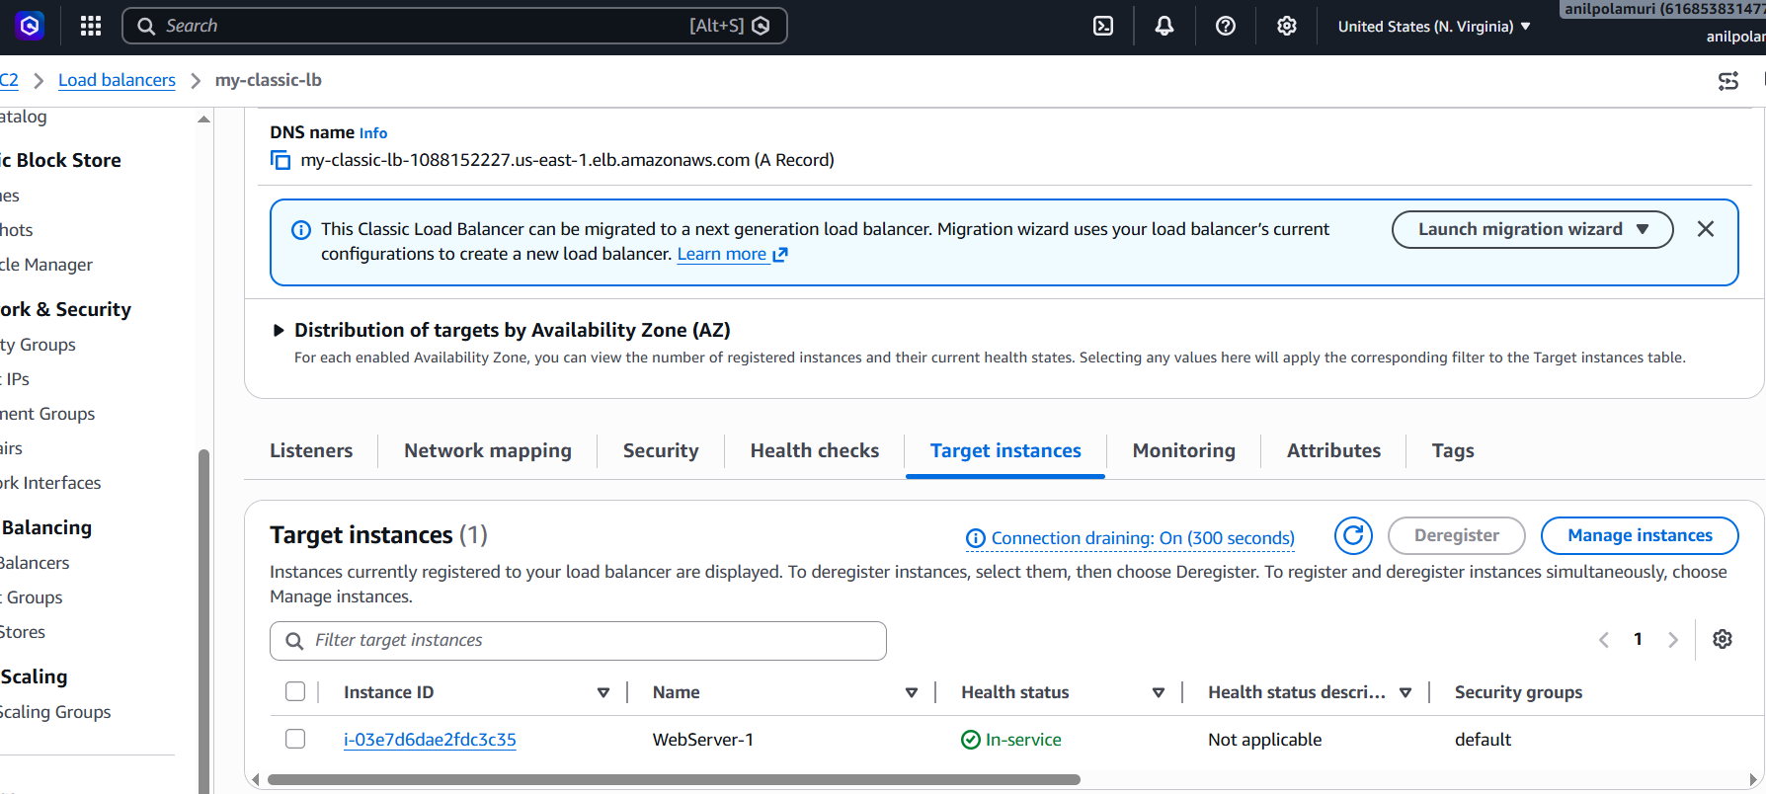
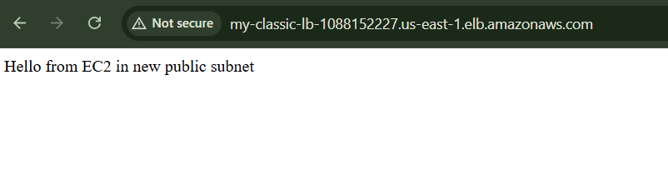

2.Configure Application Load balancer

Purpose :
We will create this architecture:
User Browser
↓
Application Load Balancer
↓
Target Group
↓
EC2 WebServer-1
When we open the ALB DNS name, it should show the Apache web page from your EC2 instance.

1. Created/used two EC2 instances
WebServer-1
WebServer-2
Purpose:
Two instances are needed to test real load balancing. Traffic can go to both servers instead of only one.

2. Connected to WebServer-1 from Git Bash
cd ~/Downloads
chmod 400 bashscript.pem
ssh -i bashscript.pem ec2-user@WebServer-1-Public-IP
Purpose:
To login into the EC2 instance and install the web server.

3. Installed Apache on WebServer-1
sudo yum update -y
sudo yum install httpd -y
sudo systemctl start httpd
sudo systemctl enable httpd
echo "Hello from WebServer-1" | sudo tee /var/www/html/index.html
Purpose:
Apache runs the website on port 80. The load balancer sends traffic to this web server.

4. Connected to WebServer-2 from Git Bash
ssh -i bashscript.pem ec2-user@WebServer-2-Public-IP
Purpose:
To configure the second backend server.

5. Installed Apache on WebServer-2
sudo yum update -y
sudo yum install httpd -y
sudo systemctl start httpd
sudo systemctl enable httpd
echo "Hello from WebServer-2" | sudo tee /var/www/html/index.html
Purpose:
To make WebServer-2 serve a different page, so we can confirm load balancing.

6. Checked Apache status on both instances
sudo systemctl status httpd
Purpose:
To verify Apache is running successfully.
Expected:
active (running)

7. Checked EC2 security group
Inbound rules allowed:
Type | Port | Source
SSH | 22 | My IP
HTTP | 80 | 0.0.0.0/0
Purpose:
SSH is needed to connect to the server. HTTP 80 is needed for ALB health checks and web traffic.

8. Tested both EC2 instances directly
Opened:
http://WebServer-1-Public-IP
http://WebServer-2-Public-IP
Purpose:
To confirm both servers are working before adding them to the load balancer.

9. Created Target Group
Settings used:
Target type: Instances
Protocol: HTTP
Port: 80
VPC: Same VPC as EC2 instances
Health check path: /
Purpose:
Target Group stores the backend EC2 instances. ALB forwards traffic to this target group.

10. Registered both EC2 instances in Target Group
Added:
WebServer-1
WebServer-2
Port:
80
Purpose:
This tells the ALB which backend servers should receive traffic.

11. Verified target health
Checked:
EC2 → Target Groups → alb-webserver-tg → Targets
Both showed:
Healthy
Purpose:
Healthy status means ALB can successfully reach both EC2 instances on port 80.

12. Created Application Load Balancer
Settings used:
Name: my-application-lb
Scheme: Internet-facing
IP address type: IPv4
VPC: Same VPC as EC2
Subnets: Two public subnets in different AZs
Purpose:
The ALB receives user traffic from the internet and distributes it to backend servers.

13. Selected two public subnets
Example:
us-east-1a subnet
us-east-1d subnet
Purpose:
ALB requires at least two Availability Zones for high availability.

14. Created/attached ALB security group
Inbound rule:
Type | Port | Source
HTTP | 80 | 0.0.0.0/0
Purpose:
Allows users to access the Application Load Balancer using HTTP.

15. Configured ALB listener
Listener:
HTTP : 80
Default action:
Forward to alb-webserver-tg
Purpose:
Listener receives HTTP requests on port 80 and forwards them to the target group.

16. Tested ALB DNS
Opened:
http://ALB-DNS-NAME
Purpose:
To confirm the ALB is reachable from the browser.

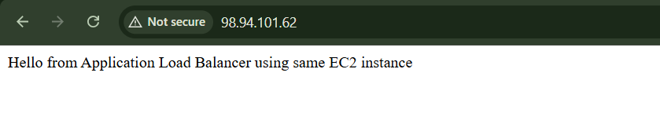
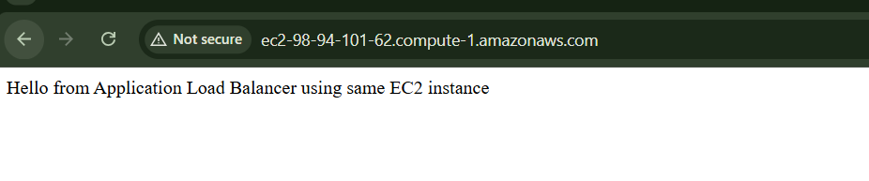
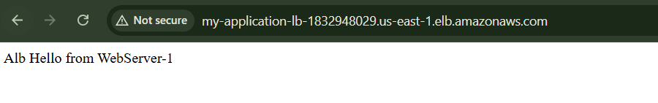
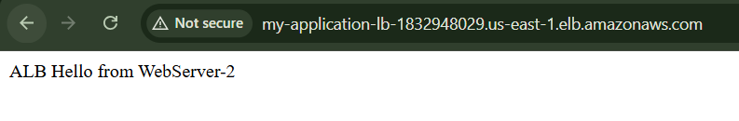

3.Configure Network Load balancer.

Network Load Balancer is used for:
- Very high-performance traffic handling
2. TCP/UDP/TLS traffic
3. Low latency applications
4. Static IP support
5. Preserving client IP
6. Handling millions of requests per second
- Use two EC2 instances: WebServer-1 and WebServer-2 — purpose: to test load distribution.
- Connect to WebServer-1 from Git Bash:
cd ~/Downloads
chmod 400 bashscript.pem
ssh -i bashscript.pem ec2-user@WebServer-1-Public-IP
- Install and start Apache on WebServer-1:
sudo yum update -y
sudo yum install httpd -y
sudo systemctl start httpd
sudo systemctl enable httpd
echo "Hello from WebServer-1 via NLB" | sudo tee /var/www/html/index.html
- Connect to WebServer-2:
exit
ssh -i bashscript.pem ec2-user@WebServer-2-Public-IP
- Install and start Apache on WebServer-2:
sudo yum update -y
sudo yum install httpd -y
sudo systemctl start httpd
sudo systemctl enable httpd
echo "Hello from WebServer-2 via NLB" | sudo tee /var/www/html/index.html
- Check Apache on both instances:
sudo systemctl status httpd
Purpose: Apache should show active (running).
- Check EC2 security group: allow SSH 22 from My IP and HTTP 80 from 0.0.0.0/0 — purpose: allow login and NLB traffic.
- Test both EC2 public IPs in browser:
http://WebServer-1-Public-IP
http://WebServer-2-Public-IP
- Go to EC2 → Target Groups → Create target group.
- Choose target type: Instances.
- Configure target group:
Name: nlb-webserver-tg
Protocol: TCP
Port: 80
VPC: Same VPC as EC2 instances
- Configure health check:
Protocol: TCP
Port: Traffic port
- Register both instances: select WebServer-1 and WebServer-2, port 80, then create target group.
- Go to EC2 → Load Balancers → Create load balancer → Network Load Balancer.
- Configure NLB:
Name: my-network-lb
Scheme: Internet-facing
IP address type: IPv4
VPC: Same VPC as EC2
- Select public subnets in the same AZs as both instances — purpose: NLB should reach both targets.
- Configure listener:
Protocol: TCP
Port: 80
Forward to: nlb-webserver-tg
- Create Network Load Balancer.
- Check target health:
EC2 → Target Groups → nlb-webserver-tg → Targets
Both should show Healthy.
- Copy NLB DNS name and test:
http://NLB-DNS-NAME
- Test load balancing from Git Bash:
for i in {1..20}; do curl http://NLB-DNS-NAME; echo; done
Expected: responses from both WebServer-1 and WebServer-2.

Final Flow
User → Network Load Balancer TCP:80 → Target Group → WebServer-1 / WebServer-2

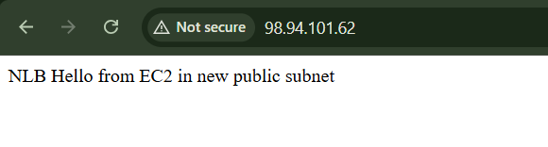

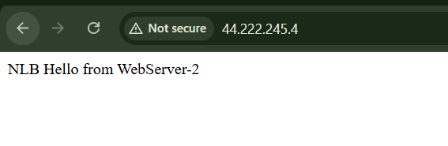

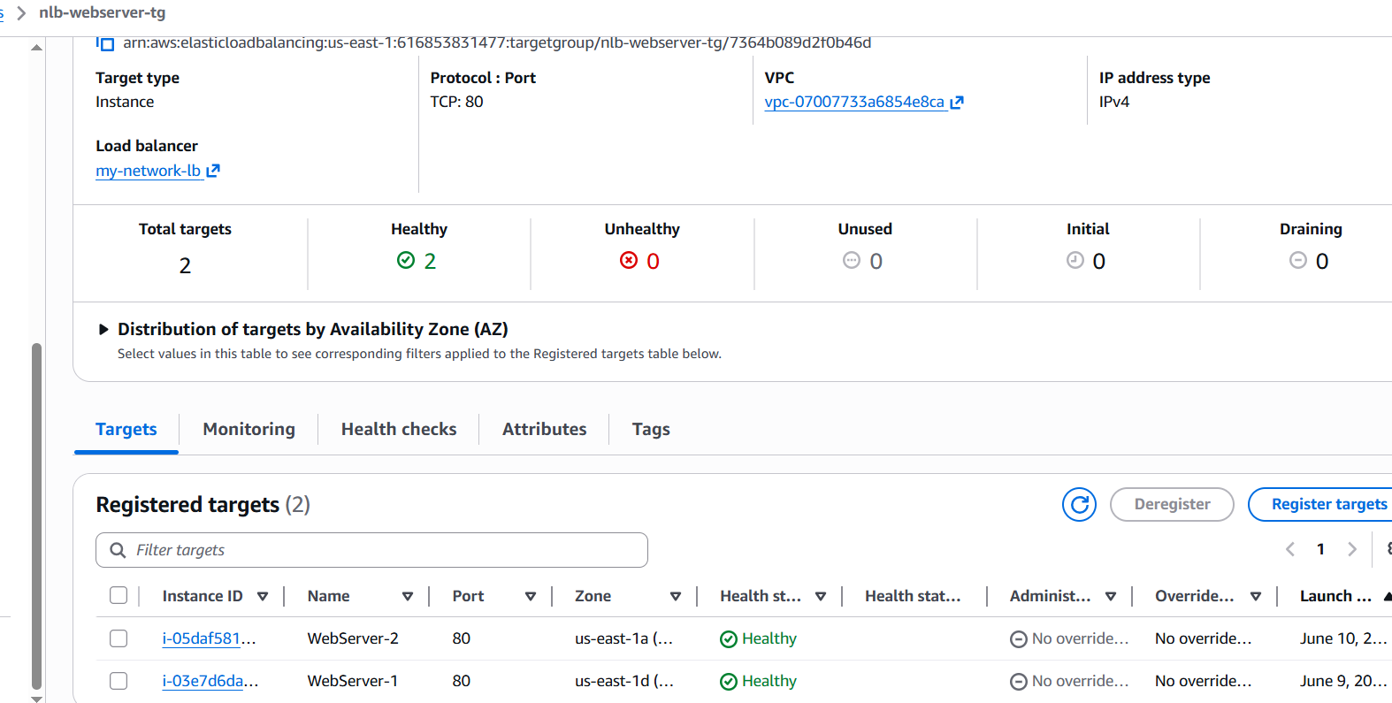
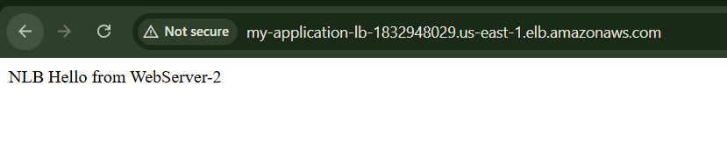

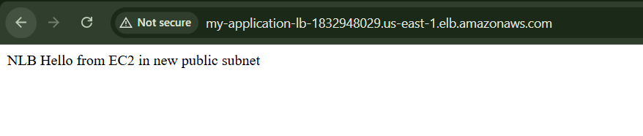

4.Attach SSL for application load balancer.

Part 1: Prerequisites
Before starting, you should have:
1. Domain: anidivops.online in GoDaddy
2. Application Load Balancer: my-application-lb
3. Target Group: alb-webserver-tg
4. WebServer-1 and WebServer-2 healthy in target group
5. ACM certificate for anidivops.online
Purpose: SSL works only when your domain, certificate, DNS, ALB listener, and security group are all connected correctly.

Part 2: Create ACM SSL Certificate

Step 1: Open Certificate Manager
Go to:
AWS Console → Search ACM → Certificate Manager
Purpose: ACM is used to create SSL/TLS certificates in AWS.

Step 2: Check region
Make sure ACM is in the same region as your ALB.
Example:
ALB region: us-east-1
ACM region: us-east-1
Purpose: ALB can use ACM certificates only from the same region.

Step 3: Request certificate
Click:
Request certificate
Select:
Request a public certificate
Click:
Next
Purpose: Public certificate is used for public websites.

Step 4: Enter domain name
Enter only:
anidivops.online
Do not enter:
app.anidivops.online
because you want only root domain.
Purpose: Certificate should match the domain you want to open.

Step 5: Select DNS validation
Choose:
DNS validation
Click:
Request
Purpose: DNS validation proves that you own the domain.

Part 3: Validate Certificate

Step 6: Open certificate details
Click the certificate:
anidivops.online
You will see:
CNAME name
CNAME value
Example:
CNAME name:
_def662e8206720c34de6391d0fd87d87.anidivops.online.
CNAME value:
_fa50a9054d00a430190b3ff2c56c0ec2.jkddzztszm.acm-validations.aws.
Purpose: This CNAME is used to validate your domain ownership.

Step 7: Add CNAME in GoDaddy DNS
Go to:
GoDaddy → My Products → anidivops.online → Manage DNS
Click:
Add New Record
Choose:
Type: CNAME
Enter:
GoDaddy Field | Value
Type | CNAME
Name / Host | _def662e8206720c34de6391d0fd87d87
Value / Points to | _fa50a9054d00a430190b3ff2c56c0ec2.jkddzztszm.acm-validations.aws
TTL | 1 Hour / Default
Important:
Do not enter the full domain in Host.
Wrong:
_def662e8206720c34de6391d0fd87d87.anidivops.online
Correct:
_def662e8206720c34de6391d0fd87d87
Purpose: GoDaddy automatically adds .anidivops.online, so only the first part is required.

Step 8: Wait for certificate status
Go back to ACM and wait.
Status should change from:
Pending validation
to:
Issued
Purpose: Only an Issued certificate can be attached to ALB.

Part 4: Create Route 53 Hosted Zone
Because you want root domain:
anidivops.online
the best way is to use Route 53 A Alias record.

Step 9: Open Route 53
Go to:
AWS Console → Route 53 → Hosted zones
Click:
Create hosted zone

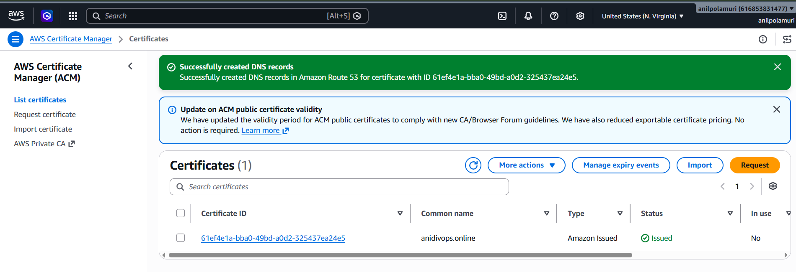
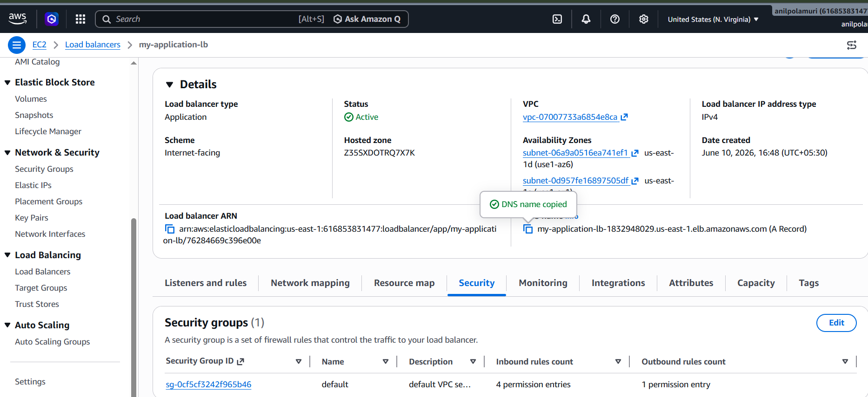

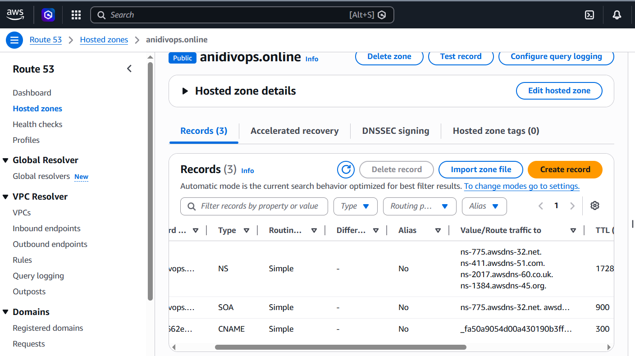

5.Map Application load balancer to R53.
• Open AWS Route 53
Purpose: To manage DNS for your domain in AWS.
• Go to Route 53 → Hosted zones
Purpose: Hosted zone stores DNS records for your domain.
• Click Create hosted zone
Purpose: To create DNS zone for your domain.
• Enter domain name: anidivops.online
Purpose: This tells Route 53 which domain you want to manage.
• Select Public hosted zone
Purpose: Public hosted zone is required for internet websites.
• Click Create hosted zone
Purpose: Route 53 will generate DNS records for your domain.
• Open the hosted zone anidivops.online
Purpose: To copy the Route 53 nameservers.
• Copy the 4 NS records from Route 53
Example:
ns-xxx.awsdns-xx.com
ns-xxx.awsdns-xx.net
ns-xxx.awsdns-xx.org
ns-xxx.awsdns-xx.co.uk
Purpose: These nameservers will replace GoDaddy nameservers.
• Go to GoDaddy
Purpose: Your domain was purchased from GoDaddy.
• Click the AniDivOps / anidivops.online card
Purpose: To open domain settings.
• Go to Manage DNS / DNS Settings
Purpose: To change DNS configuration.
• Find Nameservers section
Purpose: This shows who currently controls your DNS.
• Click Change Nameservers / Edit Nameservers
Purpose: To replace GoDaddy nameservers.
• Select “I’ll use my own nameservers” or “Custom nameservers”
Purpose: To use AWS Route 53 nameservers.
• Paste the 4 Route 53 nameservers
Purpose: This moves DNS control from GoDaddy to Route 53.
• Save nameserver changes in GoDaddy
Purpose: Now internet DNS will start using Route 53.
• Go back to AWS Route 53 hosted zone
Purpose: Now create a DNS record pointing domain to ALB.
• Click Create record
Purpose: To create DNS mapping for anidivops.online.
• Leave Record name blank
Purpose: Blank means root domain: anidivops.online.
• Select Record type: A
Purpose: Root domain uses A record.
• Enable Alias
Purpose: Alias allows root domain to point to AWS ALB.
• Choose “Alias to Application and Classic Load Balancer”
Purpose: To connect domain to your ALB.
• Select Region: us-east-1
Purpose: Your ALB is in this region.
• Select your ALB: my-application-lb
Purpose: This points anidivops.online to your Application Load Balancer.
• Click Create records
Purpose: DNS record is created.
• Go to ACM Certificate Manager
Purpose: To confirm SSL certificate.
• Check certificate for anidivops.online is Issued
Purpose: Only issued certificates can be used with ALB.
• Go to EC2 → Load Balancers → my-application-lb
Purpose: To configure HTTPS on your ALB.
• Open Listeners tab
Purpose: Listener receives traffic on ALB.
• Add HTTPS listener if not already added
Purpose: HTTPS uses port 443.
• Set Protocol: HTTPS and Port: 443
Purpose: Enables secure HTTPS traffic.
• Select ACM certificate: anidivops.online
Purpose: ALB uses this certificate for SSL.
• Set routing action: Forward to target group
Purpose: HTTPS traffic should go to your EC2 target group.
• Select target group: alb-webserver-tg
Purpose: This target group has WebServer-1 and WebServer-2.
• Save HTTPS listener
Purpose: SSL is now attached to ALB.
• Open ALB security group
Purpose: To allow HTTPS traffic.
• Add inbound rule HTTPS 443 from 0.0.0.0/0
Purpose: Allows users to access the website using HTTPS.
• Keep HTTP 80 also allowed
Purpose: Useful for testing or redirecting HTTP to HTTPS.
• Wait for DNS propagation
Purpose: Nameserver changes may take time.
• Test in browser
https://anidivops.online
Purpose: To confirm SSL and ALB are working.
• Expected result
You should see:
Hello from WebServer-1
or
Hello from WebServer-2
• Optional: Redirect HTTP to HTTPS
Go to ALB listener HTTP:80, edit action, and select redirect to:
HTTPS
Port 443
Status code 301
Purpose: Anyone opening http://anidivops.online will automatically go to https://anidivops.online

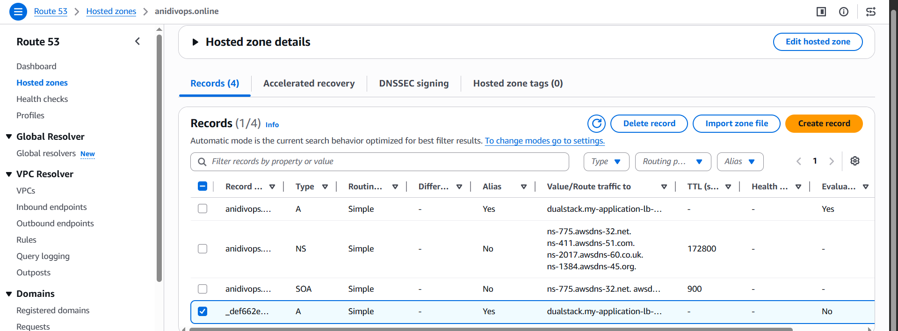
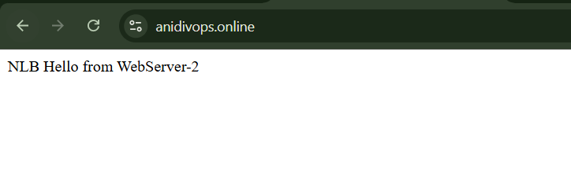

6.Push the application load balancer logs to S3.

Goal
We will enable Access logs for your Application Load Balancer and store those logs in an S3 bucket.

AWS ALB access logs capture request details such as client IP, request time, request path, latency, and response code, and store them in an S3 bucket when enabled

Part 1: Create S3 bucket for ALB logs

Step 1: Open S3
Go to:
AWS Console → Search S3 → Open S3

Step 2: Create bucket
Click:
Create bucket

Step 3: Bucket name
Enter a unique bucket name.
Example:
anidivops-alb-logs
or:
anidivops-alb-logs-616853831477
Purpose: S3 bucket names must be globally unique.

Step 4: Select region
Choose the same region as your Application Load Balancer.
Your ALB is in:
us-east-1
So select:
US East (N. Virginia) us-east-1
Purpose: AWS requires the S3 bucket for ALB logs to be in the same Region as the load balancer.

Step 5: Object ownership
Keep:
ACLs disabled
Bucket owner enforced
Purpose: This is the recommended modern S3 ownership setting.

Step 6: Block public access
Keep:
Block all public access: ON
Purpose: ALB logs are private and should not be publicly accessible.

Step 7: Bucket versioning
Keep:
Disable
Purpose: Not required for this practice task.

Step 8: Default encryption
Keep:
Server-side encryption with Amazon S3 managed keys: SSE-S3
Purpose: ALB access logs support S3-managed encryption. AWS notes that for ALB access logging, the supported server-side encryption option is S3-managed keys, SSE-S3.

Step 9: Create bucket
Click:
Create bucket

Part 2: Add S3 bucket policy

Step 10: Open your S3 bucket
Go to:
S3 → Buckets → anidivops-alb-logs
Open:
Permissions
Scroll to:
Bucket policy
Click:
Edit

Step 11: Add bucket policy
Paste this policy.
Replace:
anidivops-alb-logs
with your exact bucket name.
Replace:
616853831477
with your AWS account ID if different.
Your account ID from your previous ACM screenshot looked like:
616853831477
Use this policy:
{
"Version": "2012-10-17",
"Statement": [
{
"Sid": "AWSLogDeliveryWrite",
"Effect": "Allow",
"Principal": {
"Service": "logdelivery.elasticloadbalancing.amazonaws.com"
},
"Action": "s3:PutObject",
"Resource": "arn:aws:s3:::anidivops-alb-logs/AWSLogs/616853831477/*",
"Condition": {
"StringEquals": {
"s3:x-amz-acl": "bucket-owner-full-control"
}
}
},
{
"Sid": "AWSLogDeliveryAclCheck",
"Effect": "Allow",
"Principal": {
"Service": "logdelivery.elasticloadbalancing.amazonaws.com"
},
"Action": "s3:GetBucketAcl",
"Resource": "arn:aws:s3:::anidivops-alb-logs"
}
]
}
Purpose: The bucket policy gives Elastic Load Balancing permission to write log files into your S3 bucket. AWS says the bucket must have a policy that grants Elastic Load Balancing permission to write to it.
Click:
Save changes

Part 3: Enable access logs on Application Load Balancer

Step 12: Open Load Balancers
Go to:
EC2 → Load Balancers
Select your Application Load Balancer:
my-application-lb

Step 13: Open Attributes tab
Click:
Attributes
Look for:
Monitoring
Access logs
or:
Edit load balancer attributes

Step 14: Edit access logs
Click:
Edit
or:
Edit load balancer attributes
Find:
Access logs
Enable:
Access logs: On

Step 15: Enter S3 location
For S3 bucket, enter:
anidivops-alb-logs
For prefix, enter:
alb
Purpose: Prefix is optional, but it keeps your logs organized inside the bucket.
Your logs will be stored like:
s3://anidivops-alb-logs/alb/AWSLogs/616853831477/elasticloadbalancing/us-east-1/
AWS states that after access logging is enabled, Elastic Load Balancing stores logs in the S3 bucket as compressed files.
Click:
Save changes

Part 4: Generate traffic

Step 16: Open your website
Open your ALB/domain multiple times:
http://ALB-DNS-NAME

Part 5: Verify logs in S3

Step 17: Open S3 bucket
Go to:
S3 → Buckets → anidivops-alb-logs
Open folders:
alb
→ AWSLogs
→ 616853831477
→ elasticloadbalancing
→ us-east-1
Then open year/month/day folders.
Example:
alb/AWSLogs/616853831477/elasticloadbalancing/us-east-1/2026/06/11/
Purpose: This confirms ALB is pushing logs to S3.

Step 18: Wait if logs are not immediately visible
Wait:
5 to 10 minutes
AWS documentation says ALB publishes log files for each load balancer node every 5 minutes, and log delivery is eventually consistent.

Part 6: Download and read a log file

Step 19: Open log file
The log file will usually end with:
.log.gz
Download it.
Purpose: ALB stores logs in compressed gzip format.

Step 20: Read log file
You can open it using tools like:
7-Zip
WinRAR
gzip
In Git Bash, if downloaded locally:
gunzip filename.log.gz
cat filename.log
Purpose: To view the ALB access log entries.

